**EXPERIMENT 8**

SAILOR BOAT DATABASE (DDL, DML, DQL, Subquery, Joins, Set operations)

**Aim:**

* Create sailors, boats, and reserves.(foreign key)

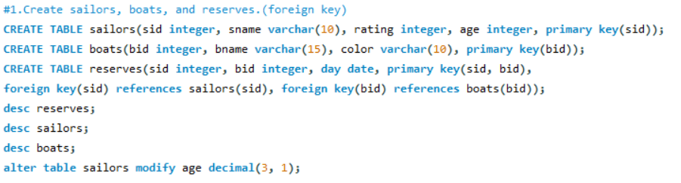

* Insert 5 values each table.

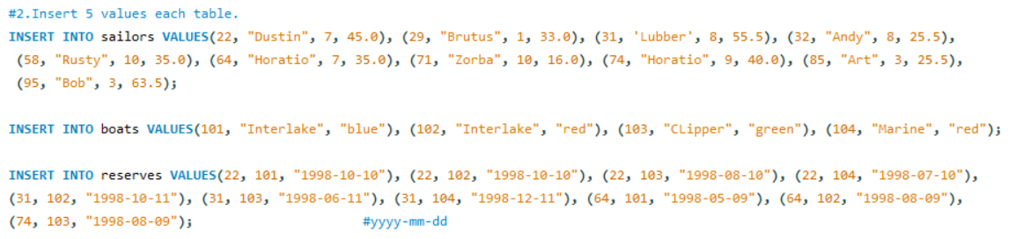

* Display all records.

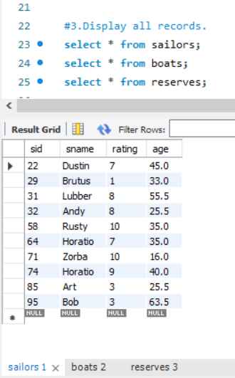 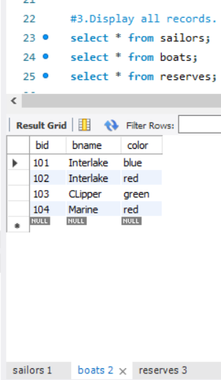 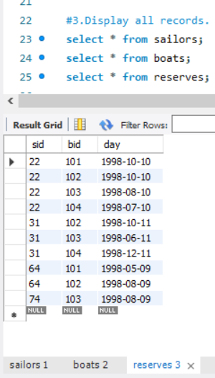

* Find the names and ages of all sailors.

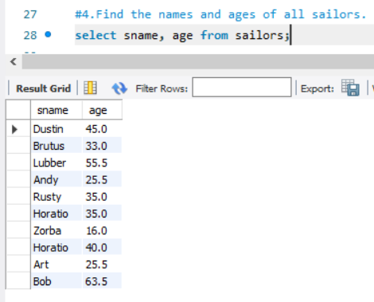

* Find all sailors with ratings above 8.

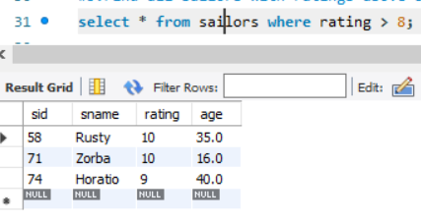

* Find sailors name with rating above 7 & age above 25.

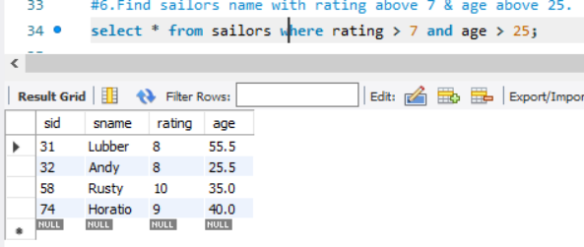

* Display all the names & colors of the boats.

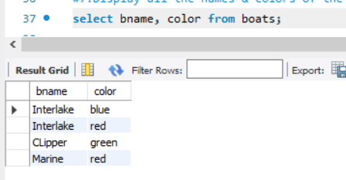

* Find all the boats with Red colors.

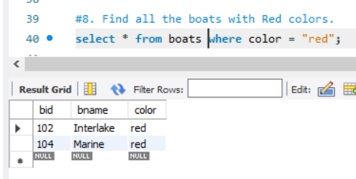

* Find the names of sailors' who have reserved boat number 103.

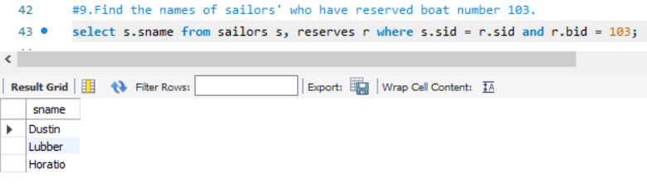

* Find the sids of sailors who have reserved blue boat

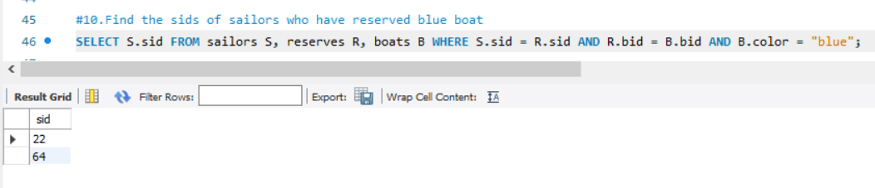

* Find the names of sailors' who have reserved Red boat.

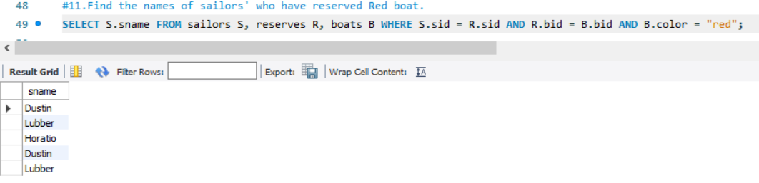

* Find the colours of boats reserved by some name(provide any name in table).

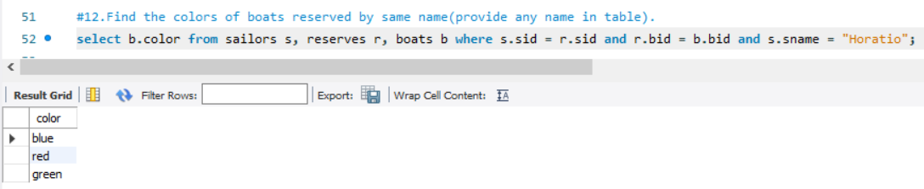

* Find the names of the sailors who have reserved at least one boat.

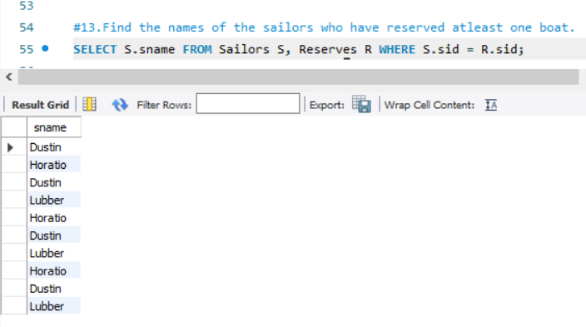

* Find the names of the sailors who have reserved two different boats.

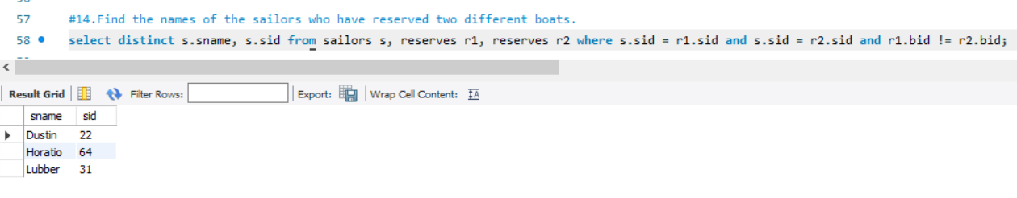

* Find the names of sailors who have reserved a Red or a Green boat.(union).

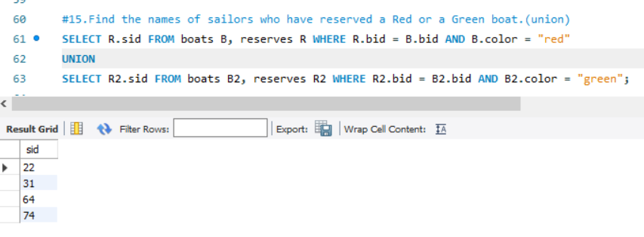

* Find the names of sailors who have reserved both a Red and a Green boat.

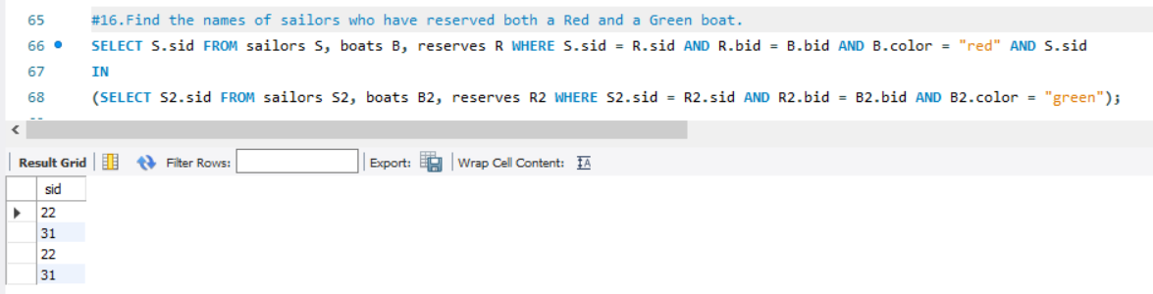

* Find the names of sailors who have reserved boat 103.(nested query).

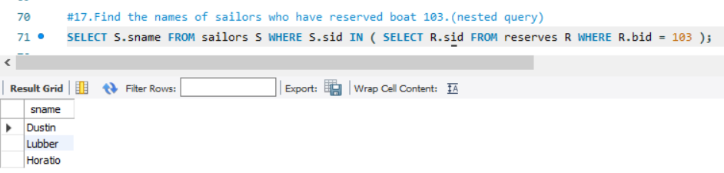

* Find the names of sailors who have reserved red boat.(nq)

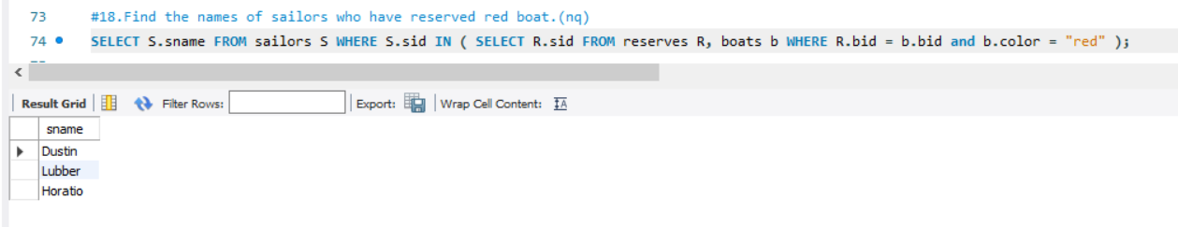

* Find the names of sailors who have not reserved red boat.(nq)

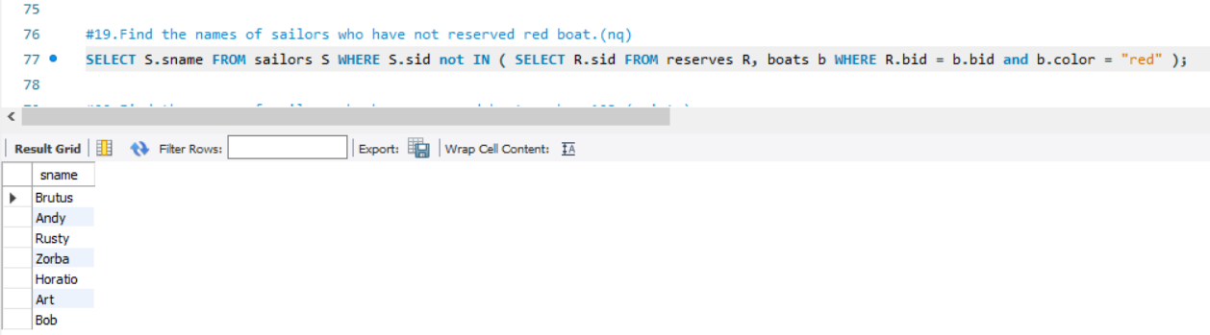

* Find the names of sailors who have reserved boat number 103.(exists)

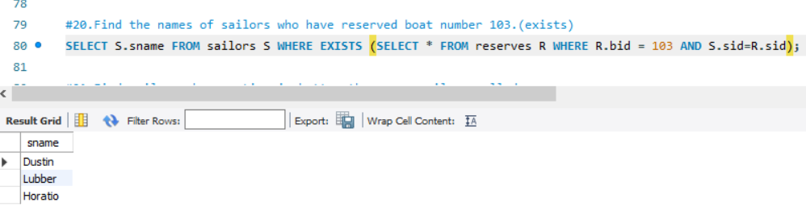

* Find sailors whose rating is better than some sailors called name.

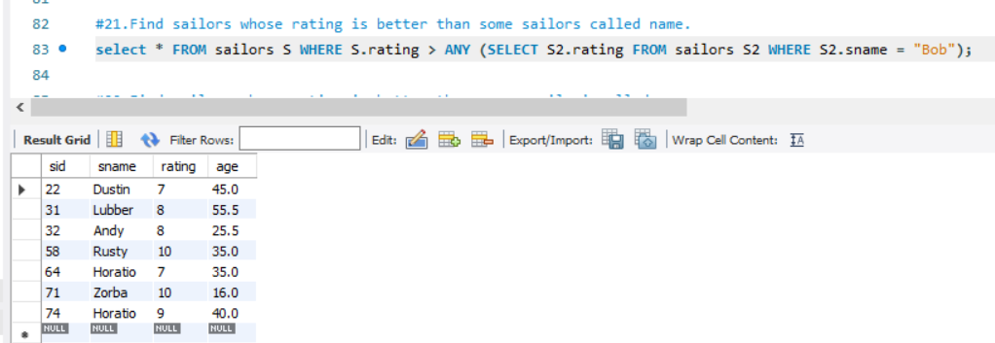

* Find sailors whose rating is better than every sailor' called name.

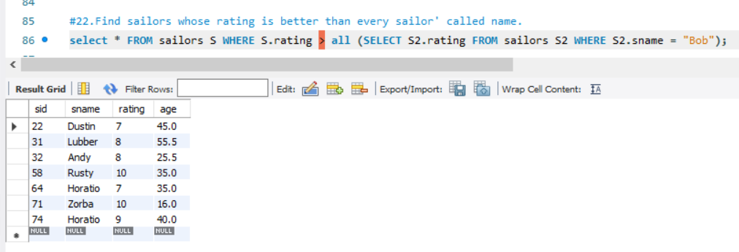

* Find the sailors with highest rating.

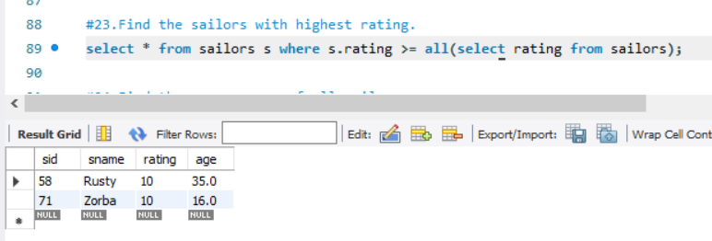

* Find the average age of all sailors.

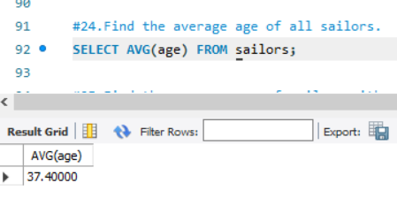

* Find the average age of sailors with a rating of 10.

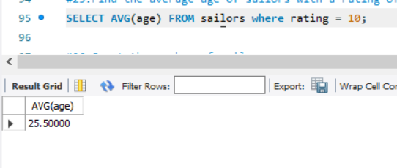

* Count the number of sailors.

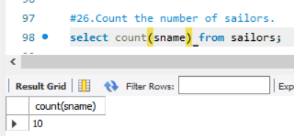

* Count the number of different sailor ratings.

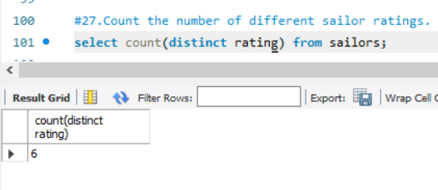

* Find the name and age of the oldest sailor.

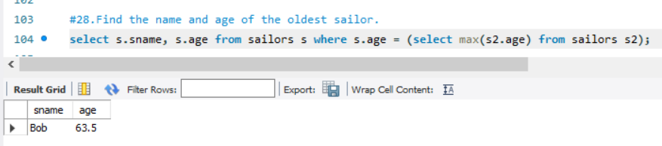

* Find the names of the sailors who are older than the oldest sailor with a rating of 10.

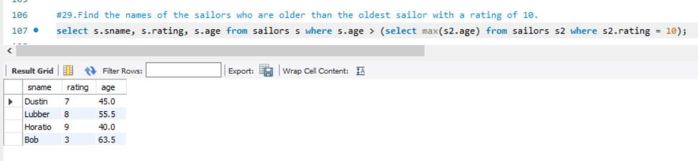

* Find the age of youngest sailor for each rating level.

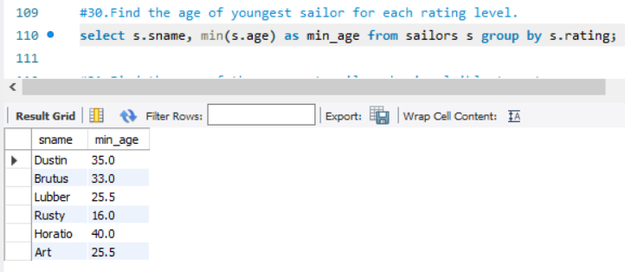

* Find the age of the youngest sailor who is eligible to vote (i.e., is at least 18 years old) for each rating level with at least two such sailors.

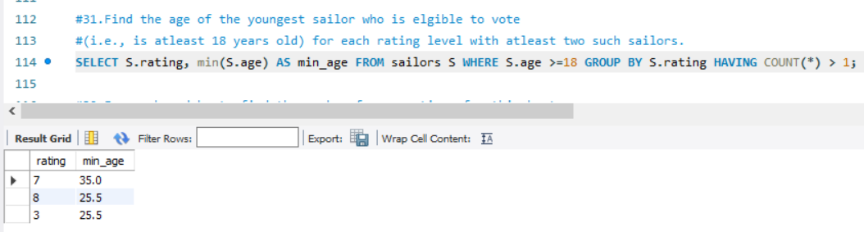

* For each red boat, find the number of reservations for this boat.

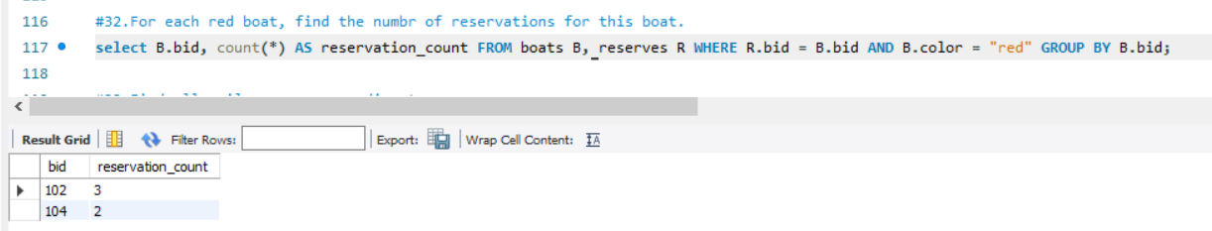

* Find all sailors name according to names.

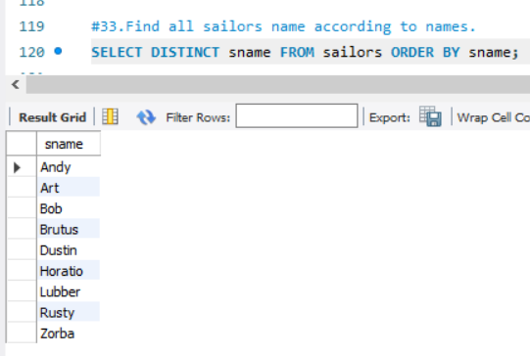

* Find all sailors details according to rating.

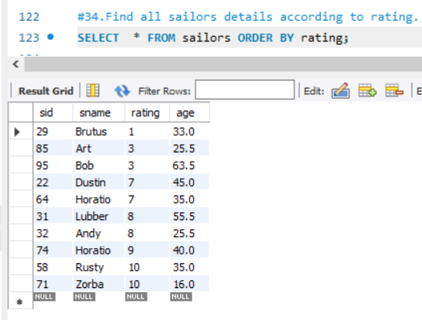

* Find all sailors details according to rating(highest first) if ratings are same then according to age(youngest first).

